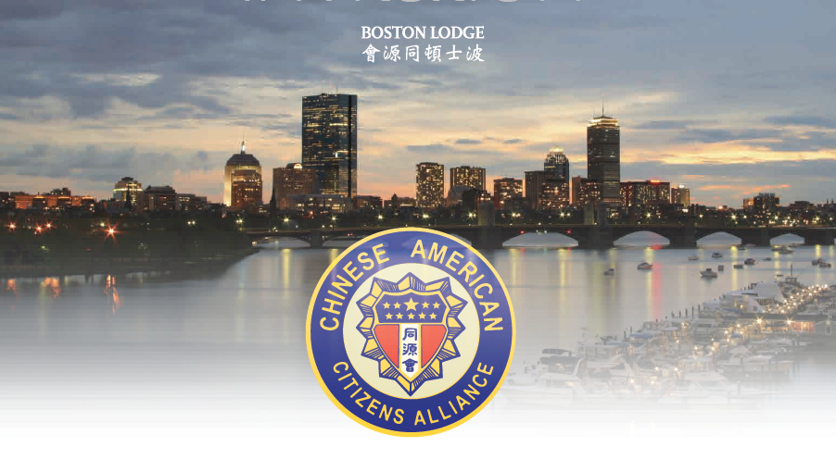
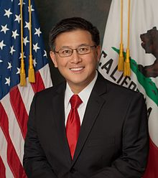

Keynote Speaker
John Chiang 江俊輝
California State Treasurer

Chinese American Citizens Alliance Boston Lodge
2nd Annual U.S. Senator George Frisbie Hoar Award Gala

Awardees
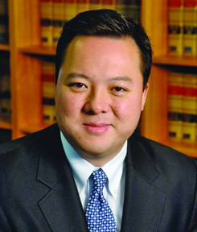
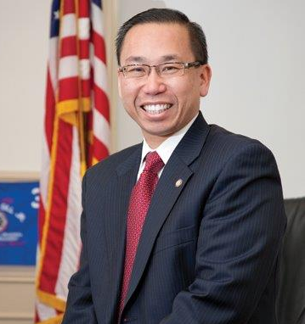
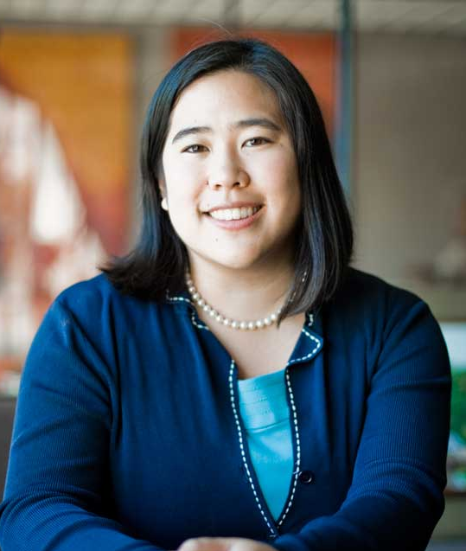
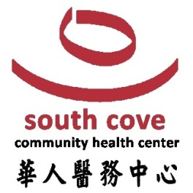

Allan Fung 馮偉傑 William Tong 湯偉麟 Lisa Wong 黃素芬 Spirit of New England Award
Mayor of Cranston, RI Connecticut State Representative Mayor of Fitchburg

Guests of Honor

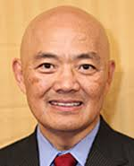
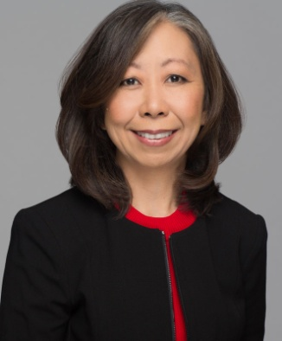
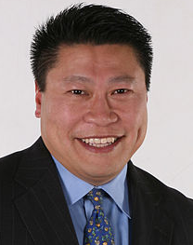
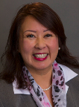

Tony Hwang 黃濤 Karen Kwan 関玉嬚 Amy Mah Sangiolo 馬惠美 Edmond Gor 敖錦賜
Connecticut State Senator Utah State Representative Newton City Councilor C.A.C.A. National President

Honorary Hosts Committee
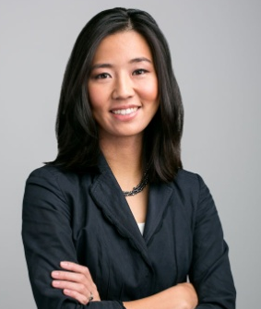
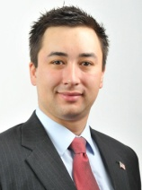
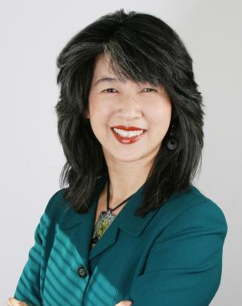
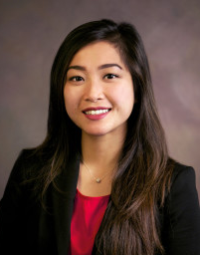
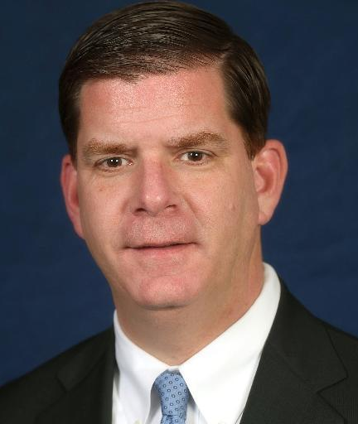

Michelle Wu 吴弭 Nina Liang 梁秀婷 Mayor Martin J Walsh Leland Cheung 张礼能 Greer Tan Swiston 談繼欣
Boston City Council President Quincy City Councilor-At-Large Boston, Massachusetts Cambridge City Councilor Newton Aldermen

On Saturday, August 19, 2017 from 6:00 pm to 9:00 pm
Hei La Moon Restaurant - 88 Beach Street, Boston, MA

Please register at: https://goo.gl/forms/uOgvIAvvUCZsbCfW2
Please call 617-658-3318 or email cacabostonlodge@gmail.com to reserve your tickets
$38 per guest or $350 for a table of 10 guests

