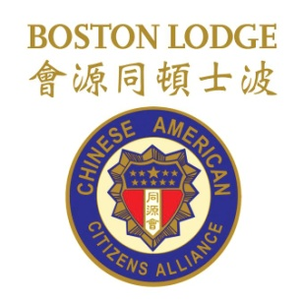
The honor of your presence is requested
at the
Chinese American Citizens Alliance Boston Lodge
Officers Inauguration Ceremony and Lunch
on
Sunday, January 31, 2016
12:30 pm – 2:00 pm
at Empire Garden Restaurant,
690 Washington Street, Boston, Massachusetts

Special Honor Guests:
Fremont, California Vice Mayor Suzanne Lee Chan
and Doctor Steven D. Chan

Cost: $20 per person

