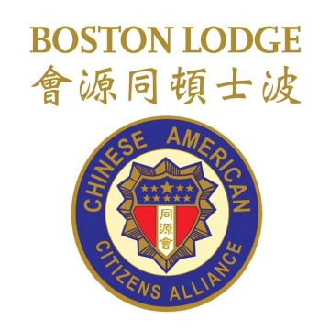

11:00 am "The Making of Asian America" - Professor Erika Lee
12:00 pm Questions and Answers - Professor Erika Lee
12:15 pm Book Signing - Professor Erika Lee

12:45 pm "Through Chinatown's Eyes" - Penny Lee
1:15 pm Questions and Answers - Penny Lee

